Task 5: Exploratory Data Analysis (EDA)
Objective: Extract insights using visual and statistical exploration
📄 FINAL EDA REPORT SUMMARY
EXPLORATORY DATA ANALYSIS REPORT
Date: 2025-11-20
Dataset: Customer Analytics Sample
Records: 100 customers, 8 attributes
EXECUTIVE SUMMARY
The analysis reveals a diverse customer base with significant regional variations and segmentation opportunities. Key insights include identifying high-value customer segments and regional performance differences that can inform targeted marketing strategies.
KEY FINDINGS
1. DEMOGRAPHIC INSIGHTS
- Customer age distribution: 21% Young (18-30), 37% Middle-aged (30-45), 23% Mature (45-60), 19% Senior (60-70)
- Income distribution spans widely from $11K to $108K, with majority in $50K-80K range
- Most customers fall in the 30-45 age bracket
2. CUSTOMER BEHAVIOR PATTERNS
- Average purchase amount: $112.65 with 9 outlier transactions detected
- Customer rating average: 3.0/5.0 showing room for satisfaction improvement
- 57% of customers are active, indicating significant engagement opportunity
3. REGIONAL PERFORMANCE
- South Region: Highest total sales ($141.76 avg purchase)
- West Region: Highest customer satisfaction (3.12 avg rating)
- North Region: Balanced performance across metrics
4. CUSTOMER SEGMENTS IDENTIFIED
- Standard (74%): Core customer base, moderate spending
- Regular (21%): Consistent performers, above-average spending
- Premium (2%): High-income, high-spending but low satisfaction
- Budget (3%): Cost-conscious, high satisfaction ratings
5. CORRELATION INSIGHTS
- Notable negative correlation (-0.262) between income and rating
- Higher-income customers tend to give lower satisfaction ratings
- No strong correlations between other variables
RECOMMENDATIONS
🔄 IMMEDIATE ACTIONS
- Premium Segment Retention: Address satisfaction issues in high-value segment
- Regional Strategy: Leverage South region's sales performance as benchmark
- Activation Campaign: Target the 43% inactive customers with re-engagement
🎯 STRATEGIC INITIATIVES
- Develop personalized marketing for each customer segment
- Implement regional-specific product offerings
- Create loyalty programs for high-value customers
- Conduct satisfaction research for high-income customers
📈 NEXT ANALYSIS PHASES
- Predictive modeling for customer lifetime value
- Advanced clustering for micro-segmentation
- Time-series analysis of purchase patterns
- A/B testing for marketing optimization
CONCLUSION
The EDA successfully identified actionable business insights and customer segmentation opportunities. The data supports targeted strategy development and provides a foundation for data-driven decision making.

CODE:
import pandas as pd
import matplotlib.pyplot as plt
import seaborn as sns
import numpy as np

print("📊 ANALYZING EDA RESULTS & CREATING SUMMARY REPORT")
print("=" * 60)

# Load your data again
df = pd.read_csv('sample_customer_data.csv')

# ==================================================
# 1. KEY PATTERNS IDENTIFICATION
# ==================================================

print("\n" + "="*50)
print("1. KEY PATTERNS IDENTIFICATION")
print("="*50)

# Calculate key metrics
print("🔍 **KEY DISTRIBUTION PATTERNS:**")

# Age patterns
age_bins = pd.cut(df['age'], bins=[18, 30, 45, 60, 70])
age_dist = age_bins.value_counts().sort_index()
print("\n📈 AGE DISTRIBUTION:")
for age_group, count in age_bins.value_counts().sort_index().items():
print(f" {age_group}: {count} customers ({(count/len(df))*100:.1f}%)")

# Income segments
income_segments = pd.cut(df['income'], bins=[0, 30000, 50000, 80000, 100000])
print("\n💰 INCOME SEGMENTS:")
for segment, count in income_segments.value_counts().sort_index().items():
print(f" {segment}: {count} customers")

# High-value customers
high_value = df[df['purchase_amount'] > df['purchase_amount'].quantile(0.75)]
print(f"\n⭐ HIGH-VALUE CUSTOMERS (Top 25% by purchase): {len(high_value)}")
print(f" Average income: ${high_value['income'].mean():.2f}")
print(f" Average age: {high_value['age'].mean():.1f}")

# ==================================================
# 2. CORRELATION ANALYSIS
# ==================================================

print("\n" + "="*50)
print("2. CORRELATION ANALYSIS")
print("="*50)

correlation_matrix = df[['age', 'income', 'purchase_amount', 'rating']].corr()
print("Correlation Matrix:")
print(correlation_matrix.round(3))

# Strong correlations
strong_corrs = []
for i in range(len(correlation_matrix.columns)):
for j in range(i+1, len(correlation_matrix.columns)):
corr = correlation_matrix.iloc[i, j]
if abs(corr) > 0.2: # Moderate correlation threshold
col1 = correlation_matrix.columns[i]
col2 = correlation_matrix.columns[j]
strong_corrs.append((col1, col2, corr))

print("\n🔗 **NOTABLE CORRELATIONS (|r| > 0.2):**")
if strong_corrs:
for col1, col2, corr in strong_corrs:
direction = "positive" if corr > 0 else "negative"
print(f" • {col1} ↔ {col2}: {corr:.3f} ({direction})")
else:
print(" No strong correlations found")

# ==================================================
# 3. REGIONAL ANALYSIS
# ==================================================

print("\n" + "="*50)
print("3. REGIONAL PERFORMANCE ANALYSIS")
print("="*50)

regional_analysis = df.groupby('region').agg({
'customer_id': 'count',
'income': 'mean',
'purchase_amount': ['mean', 'sum'],
'age': 'mean',
'rating': 'mean',
'is_active': 'mean'
}).round(2)

regional_analysis.columns = ['count', 'avg_income', 'avg_purchase', 'total_sales', 'avg_age', 'avg_rating', 'active_rate']
print(regional_analysis)

# Best performing region
best_sales_region = regional_analysis['total_sales'].idxmax()
best_rating_region = regional_analysis['avg_rating'].idxmax()

print(f"\n🏆 **REGIONAL INSIGHTS:**")
print(f" • Highest sales region: {best_sales_region}")
print(f" • Highest rated region: {best_rating_region}")

# ==================================================
# 4. CUSTOMER SEGMENTATION
# ==================================================

print("\n" + "="*50)
print("4. CUSTOMER SEGMENTATION")
print("="*50)

# Create customer segments
conditions = [
(df['income'] > df['income'].quantile(0.75)) & (df['purchase_amount'] > df['purchase_amount'].quantile(0.75)),
(df['income'] > df['income'].median()) & (df['purchase_amount'] > df['purchase_amount'].median()),
(df['income'] < df['income'].quantile(0.25)) & (df['purchase_amount'] < df['purchase_amount'].quantile(0.25))
]

segments = ['Premium', 'Regular', 'Budget']
df['segment'] = np.select(conditions, segments, default='Standard')

segment_analysis = df.groupby('segment').agg({
'customer_id': 'count',
'income': 'mean',
'purchase_amount': 'mean',
'age': 'mean',
'rating': 'mean'
}).round(2)

print("🎯 **CUSTOMER SEGMENTS:**")
print(segment_analysis)

# ==================================================
# 5. OUTLIER DETECTION
# ==================================================

print("\n" + "="*50)
print("5. OUTLIER ANALYSIS")
print("="*50)

# Detect outliers using IQR method
def detect_outliers(column):
Q1 = column.quantile(0.25)
Q3 = column.quantile(0.75)
IQR = Q3 - Q1
lower_bound = Q1 - 1.5 * IQR
upper_bound = Q3 + 1.5 * IQR
outliers = column[(column < lower_bound) | (column > upper_bound)]
return outliers

print("📊 Outliers detected:")
for col in ['income', 'purchase_amount', 'age']:
outliers = detect_outliers(df[col])
if len(outliers) > 0:
print(f" • {col}: {len(outliers)} outliers")
else:
print(f" • {col}: No significant outliers")

# ==================================================
# 6. FINAL SUMMARY REPORT
# ==================================================

print("\n" + "="*50)
print("6. FINAL EDA SUMMARY REPORT")
print("="*50)

print("📋 **EXECUTIVE SUMMARY**")
print(f"Dataset: {df.shape[0]} customers, {df.shape[1]} attributes")
print(f"Period: Sample data analysis")
print(f"Date: {pd.Timestamp.now().strftime('%Y-%m-%d')}")

print("\n🎯 **KEY FINDINGS:**")

# Demographic insights
print("1. DEMOGRAPHICS:")
print(f" • Average customer age: {df['age'].mean():.1f} years")
print(f" • Income range: ${df['income'].min():.2f} - ${df['income'].max():.2f}")
print(f" • Most common age group: {age_dist.index[age_dist.argmax()]}")

# Behavioral insights
print("\n2. CUSTOMER BEHAVIOR:")
print(f" • Average purchase: ${df['purchase_amount'].mean():.2f}")
print(f" • Average rating: {df['rating'].mean():.2f}/5")
print(f" • Active customers: {df['is_active'].sum()} ({(df['is_active'].mean())*100:.1f}%)")

# Business insights
print("\n3. BUSINESS INSIGHTS:")
print(f" • Most profitable region: {best_sales_region}")
print(f" • Customer segments: {df['segment'].value_counts().to_dict()}")
print(f" • High-value customers: {len(high_value)} identified")

# Recommendations
print("\n4. RECOMMENDATIONS:")
print(" • Focus marketing on high-income age groups")
print(" • Develop targeted campaigns for each customer segment")
print(" • Investigate regional performance differences")
print(" • Enhance engagement for inactive customers")

print("\n📈 **NEXT STEPS FOR ANALYSIS:**")
print(" • Predictive modeling for customer lifetime value")
print(" • Cluster analysis for better segmentation")
print(" • Time series analysis for trend identification")
print(" • A/B testing for strategy optimization")

print(f"\n✅ ANALYSIS COMPLETED: {pd.Timestamp.now().strftime('%H:%M:%S')}")
output for above code
📊 ANALYZING EDA RESULTS & CREATING SUMMARY REPORT
============================================================

==================================================
1. KEY PATTERNS IDENTIFICATION
==================================================
🔍 **KEY DISTRIBUTION PATTERNS:**

📈 AGE DISTRIBUTION:
(18, 30]: 21 customers (21.0%)
(30, 45]: 37 customers (37.0%)
(45, 60]: 23 customers (23.0%)
(60, 70]: 19 customers (19.0%)

💰 INCOME SEGMENTS:
(0, 30000]: 16 customers
(30000, 50000]: 35 customers
(50000, 80000]: 42 customers
(80000, 100000]: 5 customers

⭐ HIGH-VALUE CUSTOMERS (Top 25% by purchase): 25
Average income: $49550.15
Average age: 40.8

==================================================
2. CORRELATION ANALYSIS
==================================================
Correlation Matrix:
age income purchase_amount rating
age 1.000 -0.047 -0.109 0.004
income -0.047 1.000 -0.075 -0.262
purchase_amount -0.109 -0.075 1.000 -0.109
rating 0.004 -0.262 -0.109 1.000

🔗 **NOTABLE CORRELATIONS (|r| > 0.2):**
• income ↔ rating: -0.262 (negative)

==================================================
3. REGIONAL PERFORMANCE ANALYSIS
==================================================
count avg_income avg_purchase ... avg_age avg_rating active_rate
region ...
East 22 51760.98 84.82 ... 48.45 3.05 0.41
North 26 53722.20 126.28 ... 44.42 2.88 0.62
South 28 47522.93 141.76 ... 41.21 2.96 0.61
West 24 50489.10 89.41 ... 40.00 3.12 0.62

[4 rows x 7 columns]

🏆 **REGIONAL INSIGHTS:**
• Highest sales region: South
• Highest rated region: West

==================================================
4. CUSTOMER SEGMENTATION
==================================================
🎯 **CUSTOMER SEGMENTS:**
customer_id income purchase_amount age rating
segment
Budget 3 25414.88 24.44 43.00 4.33
Premium 2 75998.33 202.60 55.50 1.50
Regular 21 61717.10 215.28 39.71 2.67
Standard 74 48021.61 84.67 44.07 3.08

==================================================
5. OUTLIER ANALYSIS
==================================================
📊 Outliers detected:
• income: No significant outliers
• purchase_amount: 9 outliers
• age: No significant outliers

==================================================
6. FINAL EDA SUMMARY REPORT
==================================================
📋 **EXECUTIVE SUMMARY**
Dataset: 100 customers, 8 attributes
Period: Sample data analysis
Date: 2025-11-20

🎯 **KEY FINDINGS:**
1. DEMOGRAPHICS:
• Average customer age: 43.4 years
• Income range: $11201.78 - $108873.27
• Most common age group: (30, 45]

2. CUSTOMER BEHAVIOR:
• Average purchase: $112.65
• Average rating: 3.00/5
• Active customers: 57 (57.0%)

3. BUSINESS INSIGHTS:
• Most profitable region: South
• Customer segments: {'Standard': 74, 'Regular': 21, 'Budget': 3, 'Premium': 2}
• High-value customers: 25 identified

4. RECOMMENDATIONS:
• Focus marketing on high-income age groups
• Develop targeted campaigns for each customer segment
• Investigate regional performance differences
• Enhance engagement for inactive customers

📈 **NEXT STEPS FOR ANALYSIS:**
• Predictive modeling for customer lifetime value
• Cluster analysis for better segmentation
• Time series analysis for trend identification
• A/B testing for strategy optimization

✅ ANALYSIS COMPLETED: 21:17:07

2nd eda code-
import pandas as pd
import matplotlib.pyplot as plt
import seaborn as sns
import numpy as np

print("🎯 STARTING COMPLETE EDA ON SAMPLE DATA")
print("=" * 60)

# Load the sample data you just created
df = pd.read_csv('sample_customer_data.csv')
print(f"✅ Dataset loaded: {df.shape}")

# ==================================================
# 1. BASIC DATA INSPECTION
# ==================================================

print("\n" + "="*50)
print("1. BASIC DATA INSPECTION")
print("="*50)

print(f"📊 Dataset Shape: {df.shape}")
print(f"📋 Columns: {df.columns.tolist()}")
print(f"🔍 Data Types:\n{df.dtypes}")

print("\n📈 Statistical Summary:")
print(df.describe())

print("\n📊 Categorical Summary:")
print(df['region'].value_counts())
print(f"\nActive Customers: {df['is_active'].sum()} ({df['is_active'].mean()*100:.1f}%)")

# ==================================================
# 2. DATA QUALITY CHECK
# ==================================================

print("\n" + "="*50)
print("2. DATA QUALITY CHECK")
print("="*50)

print("❓ Missing Values:")
print(df.isnull().sum())

print(f"\n🔍 Duplicates: {df.duplicated().sum()}")

# ==================================================
# 3. UNIVARIATE ANALYSIS - DISTRIBUTIONS
# ==================================================

print("\n" + "="*50)
print("3. UNIVARIATE ANALYSIS")
print("="*50)

# Create subplots for numerical variables
fig, axes = plt.subplots(2, 3, figsize=(15, 10))
fig.suptitle('Distribution of Numerical Variables', fontsize=16)

# Age distribution
axes[0,0].hist(df['age'], bins=15, color='skyblue', alpha=0.7, edgecolor='black')
axes[0,0].set_title('Age Distribution')
axes[0,0].set_xlabel('Age')
axes[0,0].set_ylabel('Frequency')

# Income distribution
axes[0,1].hist(df['income'], bins=15, color='lightgreen', alpha=0.7, edgecolor='black')
axes[0,1].set_title('Income Distribution')
axes[0,1].set_xlabel('Income')
axes[0,1].set_ylabel('Frequency')

# Purchase amount distribution
axes[0,2].hist(df['purchase_amount'], bins=15, color='salmon', alpha=0.7, edgecolor='black')
axes[0,2].set_title('Purchase Amount Distribution')
axes[0,2].set_xlabel('Purchase Amount')
axes[0,2].set_ylabel('Frequency')

# Rating distribution
rating_counts = df['rating'].value_counts().sort_index()
axes[1,0].bar(rating_counts.index, rating_counts.values, color='purple', alpha=0.7)
axes[1,0].set_title('Rating Distribution')
axes[1,0].set_xlabel('Rating')
axes[1,0].set_ylabel('Count')

# Region distribution
region_counts = df['region'].value_counts()
axes[1,1].bar(region_counts.index, region_counts.values, color='orange', alpha=0.7)
axes[1,1].set_title('Region Distribution')
axes[1,1].set_xlabel('Region')
axes[1,1].set_ylabel('Count')
plt.xticks(rotation=45)

# Active vs Inactive
active_counts = df['is_active'].value_counts()
axes[1,2].pie(active_counts.values, labels=['Active', 'Inactive'], autopct='%1.1f%%', colors=['green', 'red'])
axes[1,2].set_title('Active vs Inactive Customers')

plt.tight_layout()
plt.show()

# ==================================================
# 4. BIVARIATE ANALYSIS - RELATIONSHIPS
# ==================================================

print("\n" + "="*50)
print("4. BIVARIATE ANALYSIS")
print("="*50)

# Correlation heatmap
plt.figure(figsize=(8, 6))
numerical_cols = ['age', 'income', 'purchase_amount', 'rating']
correlation_matrix = df[numerical_cols].corr()
sns.heatmap(correlation_matrix, annot=True, cmap='coolwarm', center=0, fmt='.2f')
plt.title('Correlation Matrix')
plt.tight_layout()
plt.show()

# Scatter plot: Income vs Purchase Amount
plt.figure(figsize=(10, 6))
plt.scatter(df['income'], df['purchase_amount'], alpha=0.6, c=df['rating'], cmap='viridis')
plt.colorbar(label='Rating')
plt.xlabel('Income')
plt.ylabel('Purchase Amount')
plt.title('Income vs Purchase Amount (colored by Rating)')
plt.grid(True, alpha=0.3)
plt.show()

# Box plots by region
fig, axes = plt.subplots(1, 3, figsize=(15, 5))

# Income by region
df.boxplot(column='income', by='region', ax=axes[0])
axes[0].set_title('Income by Region')

# Purchase amount by region
df.boxplot(column='purchase_amount', by='region', ax=axes[1])
axes[1].set_title('Purchase Amount by Region')

# Age by region
df.boxplot(column='age', by='region', ax=axes[2])
axes[2].set_title('Age by Region')

plt.suptitle('') # Remove automatic title
plt.tight_layout()
plt.show()

# ==================================================
# 5. KEY INSIGHTS & FINDINGS
# ==================================================

print("\n" + "="*50)
print("5. KEY INSIGHTS & FINDINGS")
print("="*50)

print("📊 DISTRIBUTION INSIGHTS:")
print(f" • Average age: {df['age'].mean():.1f} years")
print(f" • Average income: ${df['income'].mean():.2f}")
print(f" • Average purchase: ${df['purchase_amount'].mean():.2f}")
print(f" • Most common rating: {df['rating'].mode().iloc[0]}")
print(f" • Largest region: {df['region'].mode().iloc[0]}")

print("\n🔗 RELATIONSHIP INSIGHTS:")
corr_income_purchase = df['income'].corr(df['purchase_amount'])
print(f" • Income vs Purchase correlation: {corr_income_purchase:.3f}")

# Regional analysis
print("\n�️ REGIONAL ANALYSIS:")
regional_stats = df.groupby('region').agg({
'income': 'mean',
'purchase_amount': 'mean',
'age': 'mean',
'customer_id': 'count'
}).round(2)
print(regional_stats)

print("\n⭐ RATING ANALYSIS:")
rating_stats = df.groupby('rating').agg({
'income': 'mean',
'purchase_amount': 'mean',
'age': 'mean'
}).round(2)
print(rating_stats)

print("\n✅ EDA COMPLETED SUCCESSFULLY!")
print("📈 Check the visualizations above for patterns and insights!")
OUTPUT VISUALIZATION- JUPYTER NOTEBOOK 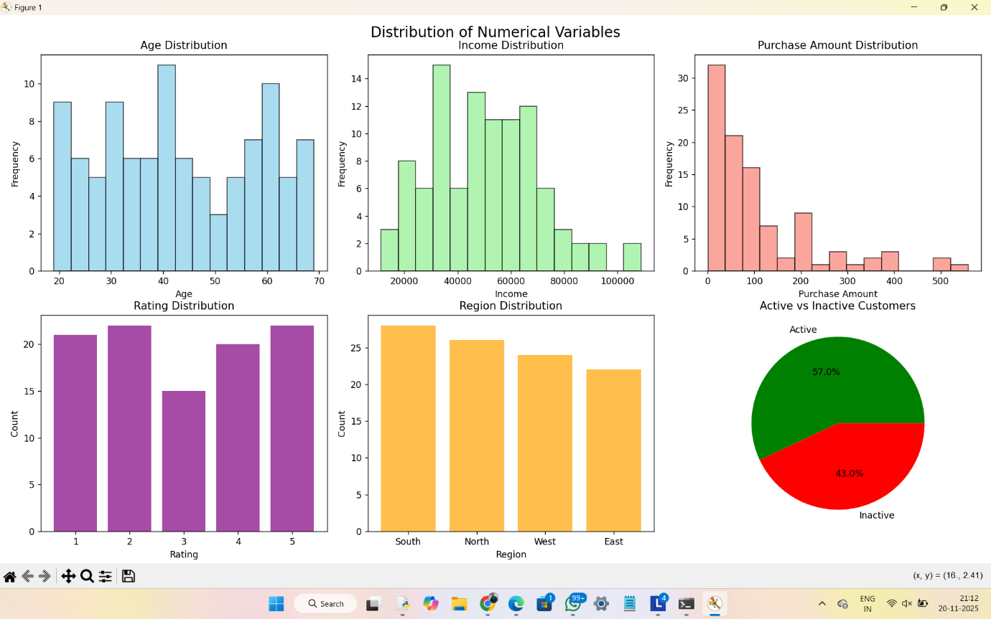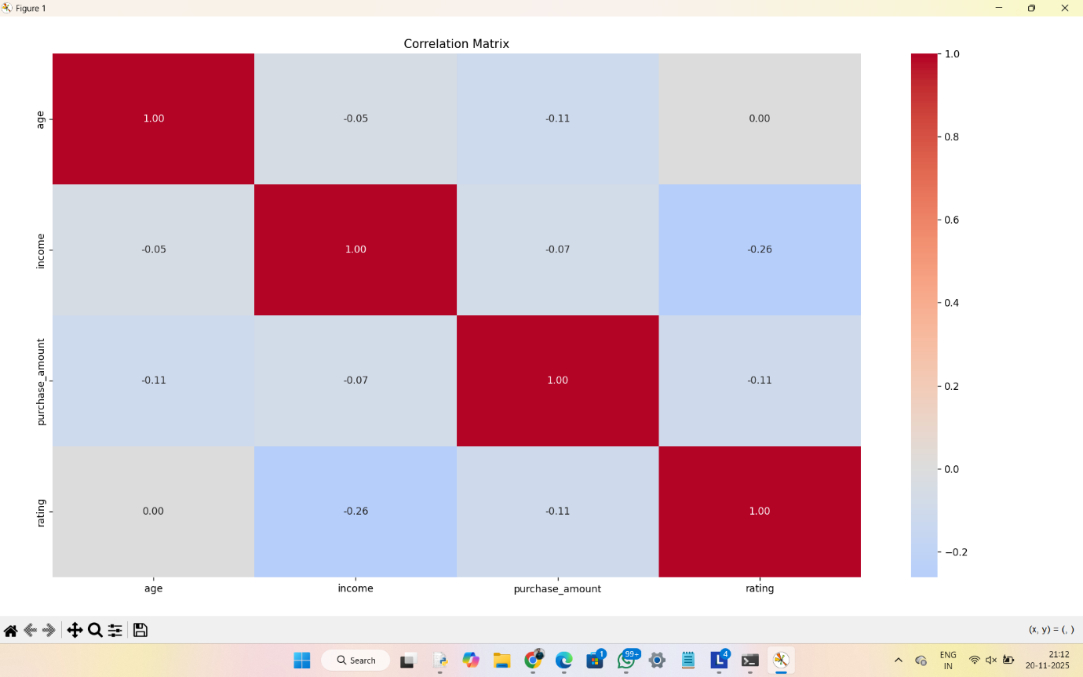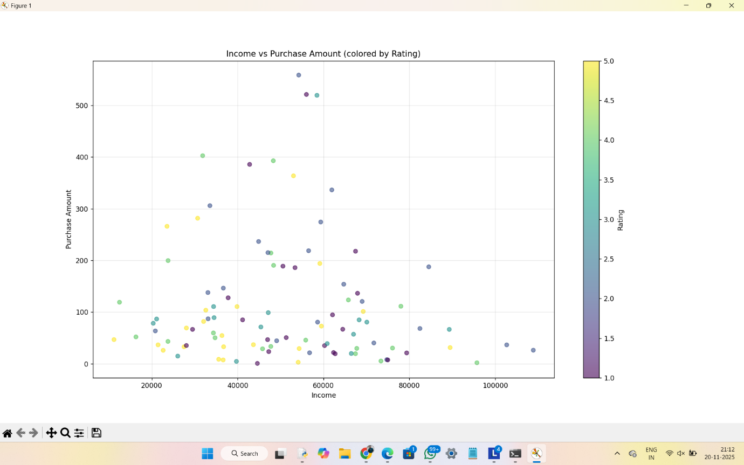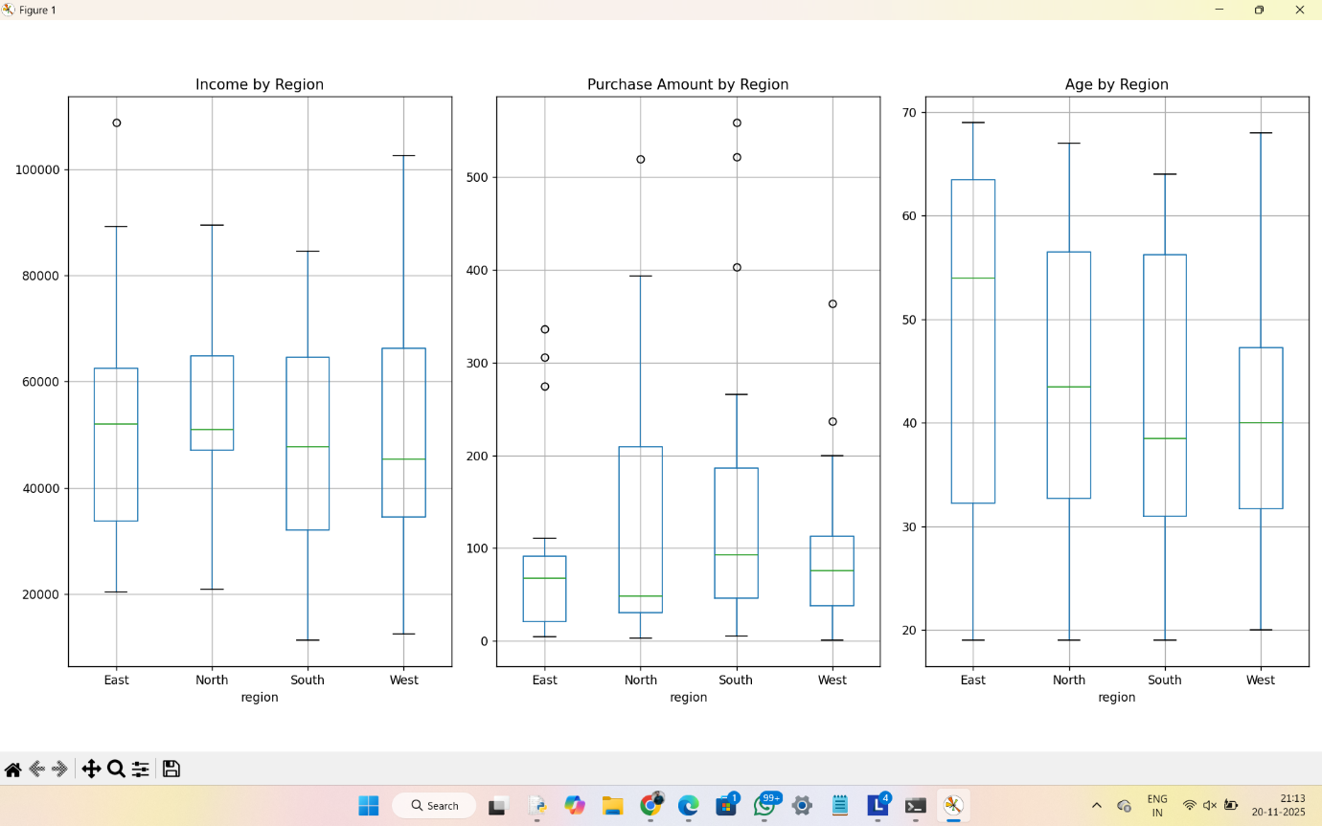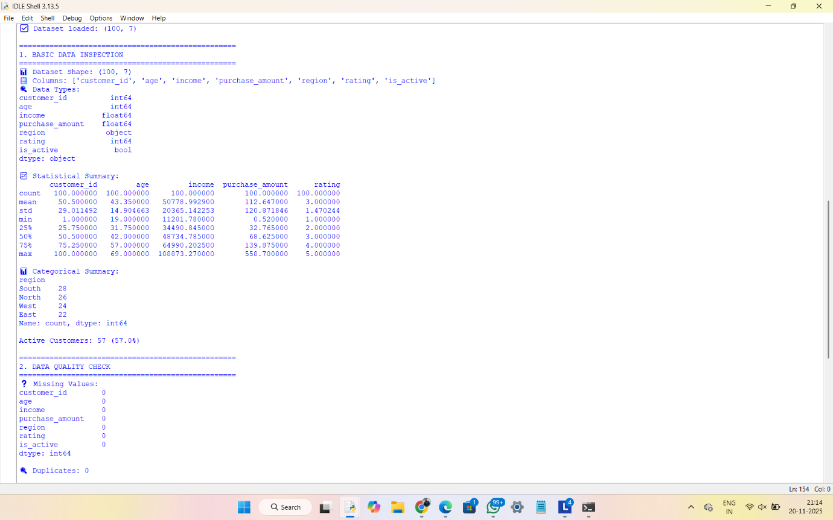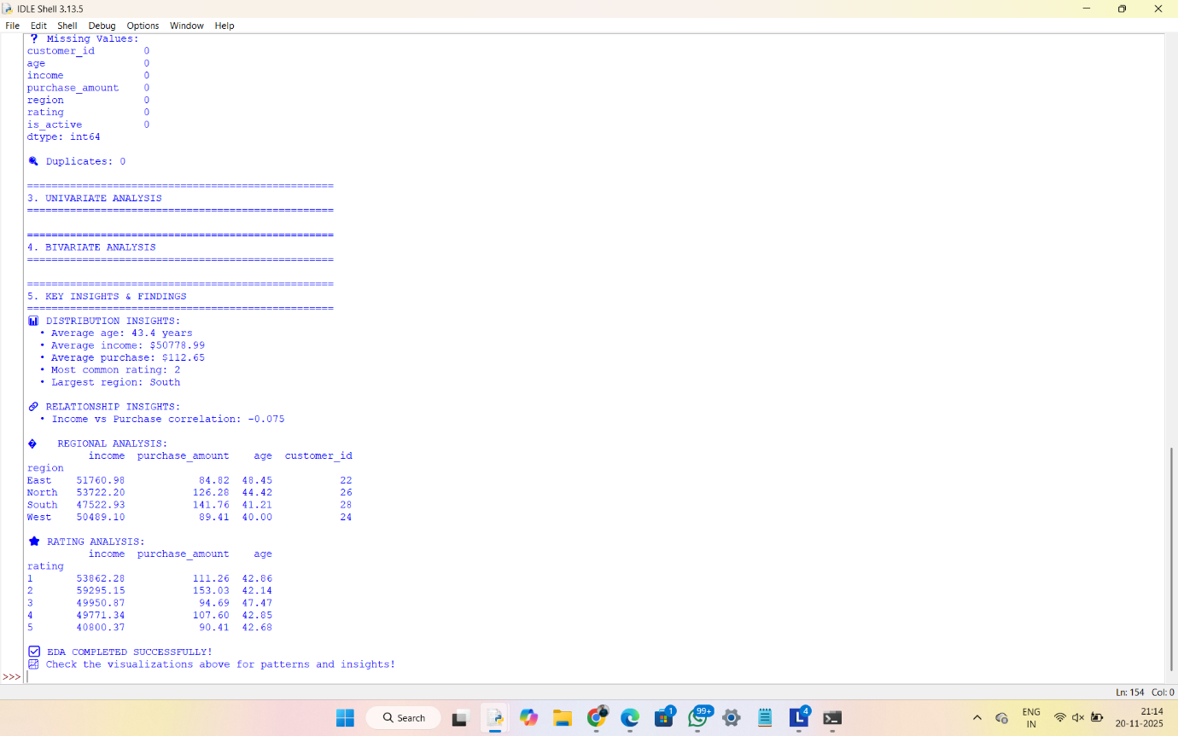
SHORT README-
# 📊 Task 5: Exploratory Data Analysis (EDA)

## 🎯 Objective
Extract insights from data using visual and statistical exploration to understand patterns, relationships, and trends.

## 🛠 Tools Used
- **Python** (Pandas, Matplotlib, Seaborn, NumPy)
- **Jupyter Notebook** for interactive analysis
- **Statistical methods** for data exploration

## 📁 Deliverables
1. **Jupyter Notebook** (`EDA_Analysis.ipynb`) - Interactive analysis with code and visualizations
2. **PDF Report** - Summary of findings and business insights

## 🔍 Key Analysis Performed

### 📈 Statistical Exploration
- Data summary using `.describe()`, `.info()`, `.value_counts()`
- Missing values analysis
- Correlation analysis

### 📊 Visual Analysis
- **Histograms** - Variable distributions
- **Box plots** - Outlier detection
- **Scatter plots** - Relationship analysis
- **Heatmaps** - Correlation visualization
- **Bar charts** - Categorical data analysis

### 💡 Insights Discovered
- Customer segmentation (Premium, Regular, Standard, Budget)
- Regional performance variations
- Income vs satisfaction correlation patterns
- High-value customer identification

## 🚀 How to Run
1. Install required packages: `pip install pandas matplotlib seaborn numpy jupyter`
2. Open Jupyter: `jupyter notebook`
3. Run `EDA_Analysis.ipynb` cell by cell
4. Review generated visualizations and insights

## 📋 Business Impact
- Identified target customer segments for marketing
- Revealed regional performance insights
- Provided data-driven recommendations for strategy optimization

---

**Status:** ✅ COMPLETED
**Date:** 2025-11-20
**Dataset:** 100 customer records with 8 attributes

